ULearn: Understanding Student Engagement/Emotion/Frustration using ML

Abstract
The goal of this work is to provide feedback to students regarding their
engagement/emotion/frustration while utilizing web-based instructional material
using computer vision and machine learning techniques. An Android Application
will be developed that will present a simple user interface of a web-browser to the
student. Based on computer vision machine learning the students facial expressions are
interpreted. If the student seems to be experiencing frustration or anger the user
is presented with a pop up giving different suggestions. If the corresponding web
Page has title, keywords and meta description tags those will be used to form
Google search links or wikipedia links. Future versions will explore the use of
Google NPL Text analysis or other web services for AI based tip generation.
Concept
Running Mode - no frustration sensed
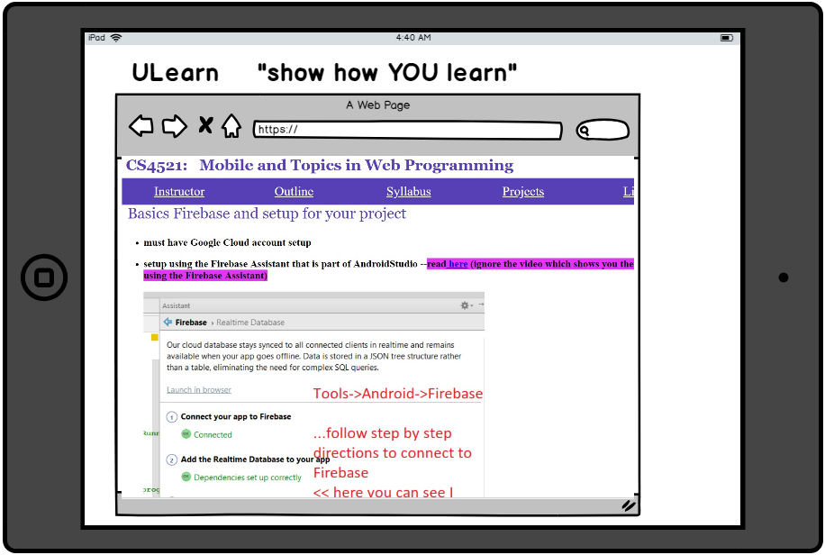
Student based View - “frustrated” case
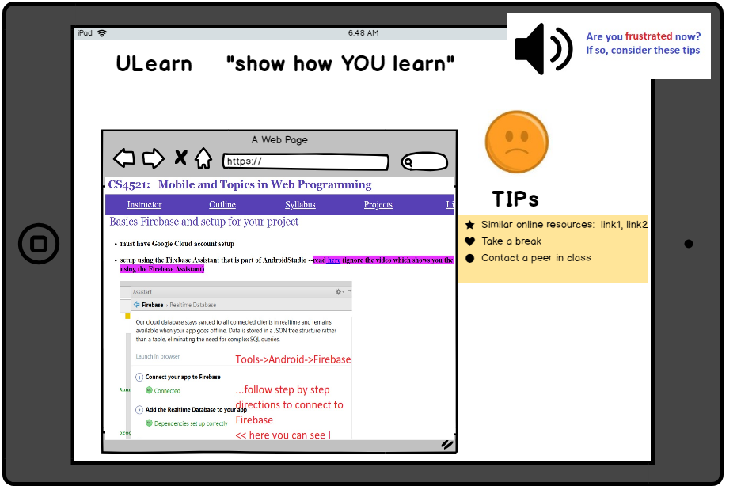
Diagnostic Mode - “happy”
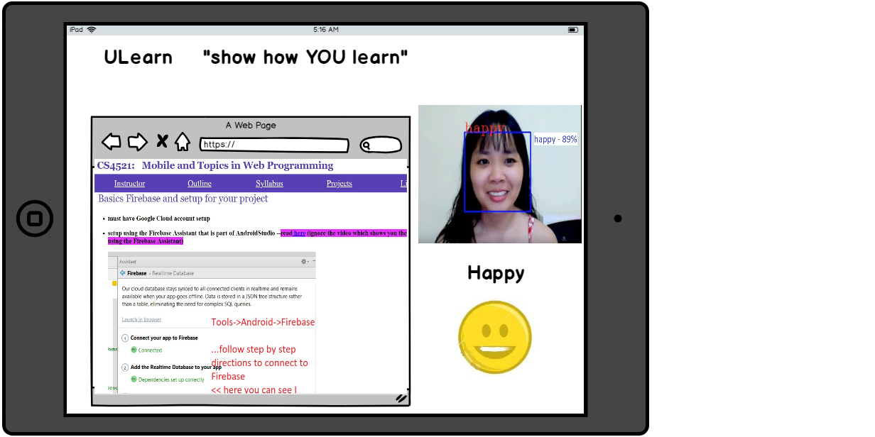
Diagnostic Mode - “frustrated”
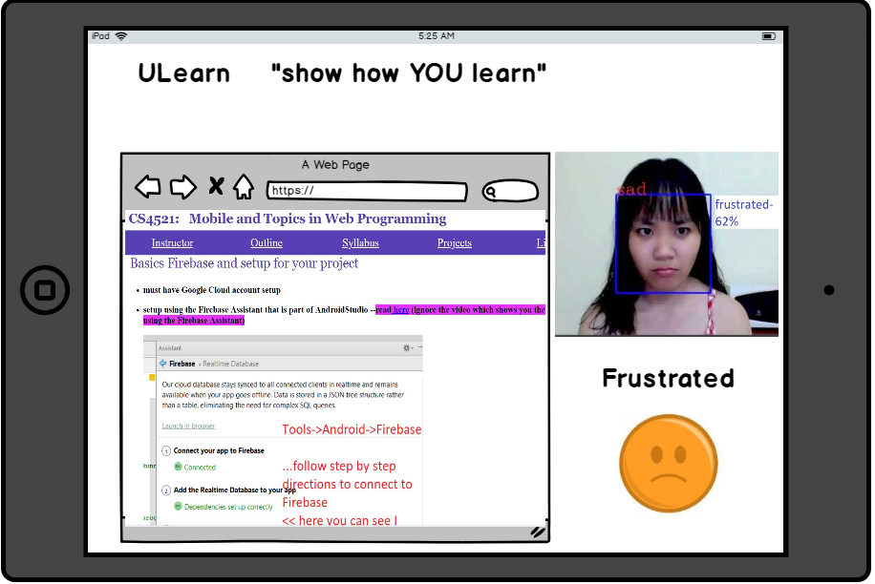

Versions
Version 1 - short 2 week deadline
Implement as above and choose either Version 1.A or Version 1.B based on availability:
Version 1.A : utilize tensorflow CNN
Version 1.B: utilize Google Cloud Face Detection service
Version 2
In addition to version 1, add some kind of customization where
faculty can in head section of HTML provide custom tips for this - maybe description is enough but, could look at more elaborate options
Version 3
Enhanced training - more time and/or with additional data beyond FER2013
Version 4
Integrate NLP semantic understanding for a AI approach to generation of tips

How it Works
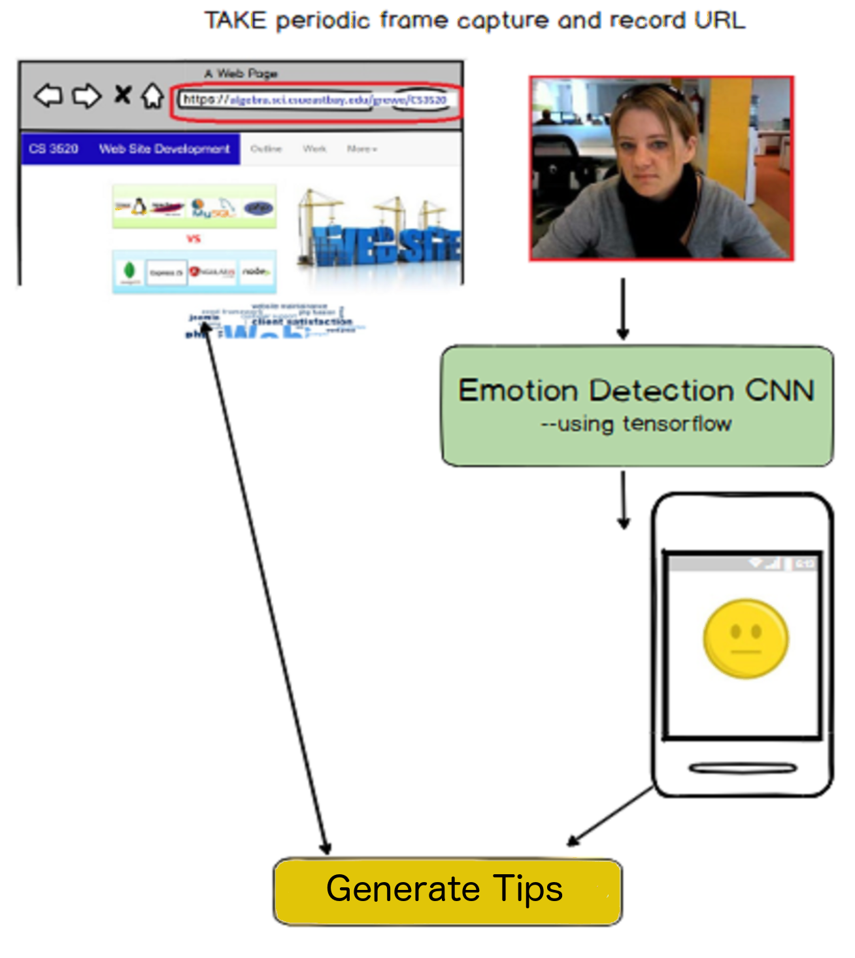
General Issues

This is a proof of concept idea and would need to be tested at the University as a research project. Providing similar links to material use Google Search API is a challenging problem and involves Natural Language Understanding which is an unsolved research problem.

Budget Issues

Use of Google services both NLP and Vision are not free

