**CS6825 Keras Tutorial**

**By a CS6825 student, Song Mei**

**See github** <https://github.com/meis725/kerasExample>

**What is Keras?**

Keras is a high-level neural networks API, written in Python and capable of running on top of [TensorFlow](https://github.com/tensorflow/tensorflow), [CNTK](https://github.com/Microsoft/cntk), or [Theano](https://github.com/Theano/Theano). It was developed with a focus on enabling fast experimentation. Being able to go from idea to result with the least possible delay is key to doing good research (keras.io).

*For more info:* <https://keras.io/>

**How to Install Keras?**

Since keras is a front-end API running on top of the tensorflow, make sure install tensorflow first before keras.

[Click here to install tensorflow](https://www.tensorflow.org/install/)

After you get your tensorflow running, here are the two options install keras:

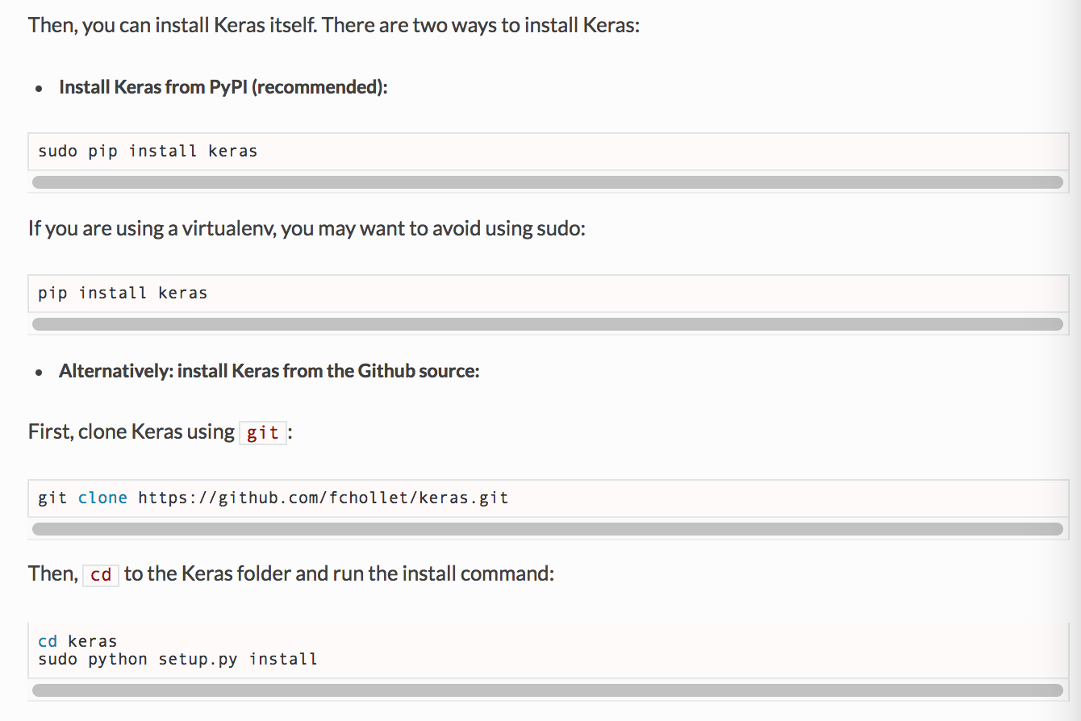

More info: <https://keras.io/>

**Working Example:** [Github repository](https://github.com/meis725/kerasExample)

This working example use to classify facial expression recognition. The size of the input image is 48 * 48. There are total 1122 training examples and 250 testing examples, I only selected a small portion of data to speed up the training. You may find the entire dataset here: [Kaggle challenge](https://www.kaggle.com/c/challenges-in-representation-learning-facial-expression-recognition-challenge).

Version info:

* Python 3.61.
* Keras 1.2.2.
* Tensorflow 1.40.
* Numpy 1.12.1.
* Pandas 0.19.2.
* Matplotlib 2.0.0.
* H5py 2.7.1.

Read comments in the example project for more info.

**Frequently asked questions:**

**Q: import error "from** keras.regularizers **import** l1, activity_l1 **"?**

**A:** Keras changed l1, activity_l1 function in keras version 2.0, check latest doc here: [Keras](https://keras.io/). Or install Keras 1.2.2.

**Q: What is the input/output node's name in my tensorflow model(.pb) file?**

**A: 1.** run "kerasToTF" function in the example code. Or check this [Keras_to_tensorflow](https://github.com/amir-abdi/keras_to_tensorflow)

**2**. Maybe you can use [Tensorboard](https://www.tensorflow.org/get_started/summaries_and_tensorboard).

**Q:** **Why the classification accuracy so low in the example program?**

**A:** Because I only included 1122 training samples to speed up the training process, the real dataset contains total 28709 examples.

**Q: Where is the output model located?**

**A**: The output model (.pb) file should appear under your project folder/tensorflow_model/constant_graph_weights.pb

**Other recommended resources:**

* [A Guide to Running Tensorflow Models on Android](https://youtu.be/kFWKdLOxykE)
  + [Project Github repository](https://github.com/llSourcell/A_Guide_to_Running_Tensorflow_Models_on_Android)
* [Good book for tensorflow](https://www.safaribooksonline.com/library/view/hands-on-machine-learning/9781491962282/)