Example - Consider a hospital Database:

Patients are treated in a single ward by the doctors assigned to them. Usually each patient will be assigned a single doctor.

Heath care assistants also attend to the patients, a number of these are associated with each ward.

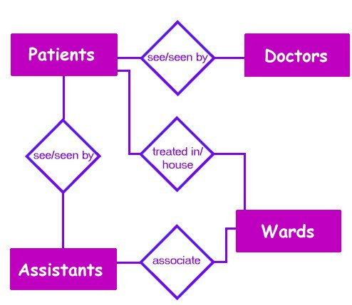

Tables to create:
Patients – PK = P_ID, foreign key = D_ID additional attributes = W_ID, A_ID
Doctors – PK = D_ID
Wards – PK = W_ID
Assistants – PK = A_ID
Assistant/Ward Associations – PK = ID, two foreign keys are W_ID and A_ID
Patient/Assistant Associations – PK = ID, two foreign keys are A_ID and P_ID

