Entity - Relationship Modeling
The aims of this tutorial are:
- To explain the need for entity-relationship modeling
- To explain the terms entity-relationship model, entity-relationship diagram
- To define the terms entity type, entity, attribute, attribute value, primary key, relationship, relationship type, inverse relationship type
- To define the grammar of entity-relationship diagrams
- To describe ways of classifying relationship types
- To describe the terms unary, binary, ternary, degree, cardinality and optionality with regard to relationship types
- To give various examples of entity-relationship modeling
3.1 Introduction
When a relational database is to be designed, an entity-relationship diagram is drawn at an early stage and developed as the requirements of the database and its processing become better understood. Drawing an entity-relationship diagram aids understanding of an organization's data needs and can serve as a schema diagram for the required system's database. A schema diagram is any diagram that attempts to show the structure of the data in a database. Nearly all systems analysis and design methodologies contain entity-relationship diagramming as an important part of the methodology and nearly all CASE (Computer Aided Software Engineering) tools contain the facility for drawing entity-relationship diagrams. An entity-relationship diagram could serve as the basis for the design of the files in a conventional file-based system as well as for a schema diagram in a database system.
The details of how to draw the diagrams vary slightly from one method to another, but they all have the same basic elements: entity types, attributes and relationships. These three categories are considered to be sufficient to model the essentially static data-based parts of any organization's information processing needs.
3.2 Entity Types
An entity type is any type of object that we wish to store data about. Which entity types you decide to include on your diagram depends on your application. In an accounting application for a business you would store data about customers, suppliers, products, invoices and payments and if the business manufactured the products, you would need to store data about materials and production steps. Each of these would be classified as an entity type because you would want to store data about each one. In an entity-relationship diagram an entity type is shown as a box. In Fig. 3.1, CUSTOMER is an entity type. Each entity type is shown once. There may be many entity types in an entity-relationship diagram. The name of an entity type is singular since it represents a type.
An entity type is considered to be a set of objects. For this reason some people use the alternative term entity set. An entity is simply one member or example or element or instance of the type or set. So an entity is one individual within an entity type. For example, within the entity type CUSTOMER, J. Smith might be one entity. He is an individual entity within the type, an element in the set, an instance of the type 'customer'.
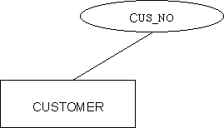
Fig. 3.1 An entity type CUSTOMER and one of its attributes Cus_no
3.3 Attributes
The data that we want to keep about each entity within an entity type is contained in attributes. An attribute is some quality about the entities that we are interested in and want to hold on the database. In fact we store the value of the attributes on the database. Each entity within the entity type will have the same set of attributes, but in general different attribute values. For example the value of the attribute ADDRESS for a customer J. Smith in a CUSTOMER entity type might be '10 Downing St., London' whereas the value of the attribute 'address' for another customer J. Major might be '22 Railway Cuttings, Cheam'.
There will be the same number of attributes for each entity within an entity type. That is one of the characteristics of entity-relationship modeling and relational databases. We store the same type of facts (attributes) about every entity within the entity type. If you knew that one of your customers happened to be your cousin, there would be no attribute to store that fact in, unless you wanted to have a 'cousin-yes-no' attribute, in which case nearly every customer would be a ‘no’, which would be considered a waste of space.
3.4 Primary Key
Attributes can be shown on the entity-relationship diagram in an oval. In Fig. 3.1, one of the attributes of the entity type CUSTOMER is shown. It is up to you which attributes you show on the diagram. In many cases an entity type may have ten or more attributes. There is often not room on the diagram to show all of the attributes, but you might choose to show an attribute that is used to identify each entity from all the others in the entity type. This attribute is known as the primary key. In some cases you might need more than one attribute in the primary key to identify the entities.
In Fig. 3.1, the attribute CUS_NO is shown. Assuming the organization storing the data ensures that each customer is allocated a different cus_no, that attribute could act as the primary key, since it identifies each customer; it distinguishes each customer from all the rest. No two customers have the same value for the attribute cus_no. Some people would say that an attribute is a candidate for being a primary key because it is ‘unique’. They mean that no two entities within that entity type can have the same value of that attribute. In practice it is best not to use that word because it has other connotations.
As already mentioned, you may need to have a group of attributes to form a primary key, rather than just one attribute, although the latter is more common. For example if the organization using the CUSTOMER entity type did not allocate a customer number to its customers, then it might be necessary to use a composite key, for example one consisting of the attributes SURNAME and INITIALS together, to distinguish between customers with common surnames such as Smith. Even this may not be sufficient in some cases.
Primary keys are not the only attributes you might want to show on the entity-relationship diagram. For example, in a manufacturing organization you might have an entity type called COMPONENT and you want to make it clear on the entity-relationship diagram that the entities within the type are not single components but a component type such as a BC109 transistor. There are thousands of BC109s in stock and any one will do for any application. It is therefore not necessary to identify each BC109 differently (they all look and work the same). However you might want to distinguish BC109s from another transistor type BC108. To make it clear that you are considering all the BC109s as one entity and all the BC108s as another entity, you might put the attribute QIS (quantity in stock) on the entity-relationship diagram as in Fig. 3.2. This makes it clearer at the entity-relationship model level that each entity in the entity type is in fact a stock item of which there will be several in stock. Any doubts on this point should be resolved by inspecting the entity description, which shows all the attributes of the entity type and (ideally) their meaning. The primary key might be STOCK_NO and one of the attributes QIS, which should remove any doubt on this point.
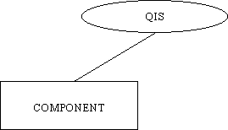
Fig. 3.2 A well-placed attribute may clarify the meaning of an entity type.
In a quality control situation however you might be interested in individual components (‘pieces’) and you would then consider each piece as an entity within the entity type BC109. STOCK_NO would not then be an adequate primary key.
Object Oriented Analysis, which is sometimes considered as an alternative to entity-relationship modeling focuses on this distinction between object and type, making it clear that it is possible for an item to be both an object (instance, entity) and a type (class, entity type) at the same time. There is generally no problem in coping with this in entity-relationship modeling provided the modeler makes clear what he or she means. In this example we have seen that the simple placing of a well-chosen attribute on the entity-relationship diagram helps clear up any ambiguity. It is an important skill of the systems analyst and database designer to be able to recognize and control such ambiguities where they arise. Careful naming of entity types is another device to enhance clarity and reduce ambiguity. Changing the name of COMPONENT to COMPONENT_TYPE would be a further improvement.
Fig. 3.3(a) uses the idea of a card file and individual cards within it as being analogous to an entity type and an entity respectively. In Fig. 3.3(b) the set - element model is used to show the same thing, and in Fig.3.3(c) the entity-relationship model for the same situation is shown. These are three different models of the same phenomenon. Notice that the entity-relationship model version does not explicitly show individual entities. You are meant to know that 'within' the entity type CUSTOMER there are lots of customer entities.

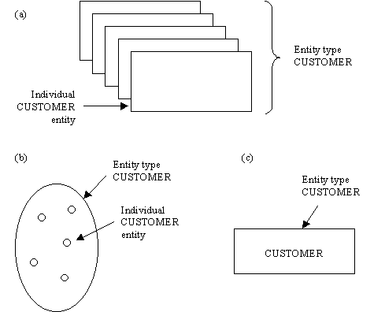
Fig. 3.3 Three ways of thinking of an entity type.
Apart from serving as an identifier for each entity within an entity type, the primary key also serves as the method of representing relationships between entities. The primary key becomes a foreign key in all those entity types to which it is related in a one-one or one-many relationship type. The concept of foreign keys is discussed later in the course.

3.5 Relationship Types
The first two major elements of entity-relationship diagrams are entity types and attributes. The final element is the relationship type. Sometimes, the word 'types' is dropped and relationship types are called simply 'relationships' but since there is a difference between the terms, one should really use the term relationship type.
Real-world entities have relationships between them, and relationships between entities on the entity-relationship diagram are shown where appropriate. An entity-relationship diagram consists of a network of entity types and connecting relationship types. A relationship type is a named association between entities. Individual entities have individual relationships of the type between them. An individual person (entity) occupies (relationship) an individual house (entity). In an entity-relationship diagram, this is generalized into entity types and relationship types. The entity type PERSON is related to the entity type HOUSE by the relationship type OCCUPIES. There are lots of individual persons, lots of individual houses, and lots of individual relationships linking them.
There can be more than one type of relationship between entities. For an example of three different relationship types between two entity types see Fig. 3.31. Fig. 3.4 shows a single relationship type 'Received' and its inverse relationship type 'Was_sent_to' between the two entity types CUSTOMER and INVOICE. It is very important to name all relationship types. The reader of the diagram must know what the relationship type means and it is up to you the designer to make the meaning clear from the relationship type name. The direction of both the relationship type and its inverse should be shown to aid clarity and immediate readability of the diagram. The tense of the relationship type should also be clear from its name.
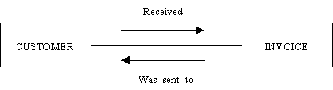
Fig. 3.4 Representing a relationship on an entity-relationship diagram.
In the development of a database system, many people will be reading the entity-relationship diagram and so it should be immediately readable and totally unambiguous. When the database is implemented, the entity-relationship diagram will continue to be used by application programmers and query writers. Misinterpretation of the model can result in many lost man-hours going down wrong tracks. There is little harm in putting redundant information into your entity-relationship model. What seems redundant to you can sometimes remove potential ambiguities for other users of your diagram. Get your user to explain your entity-relationship model to you! Then you will see how clear it is.
In Fig. 3.4 what is being 'said' is that customers received invoices and invoices were_sent_to customers. How many invoices a customer might have received (the maximum number and the minimum number) and how many customers an invoice might have been sent to, is shown by the degree of the relationship type. The 'degree' of relationship types is defined below.
In Fig. 3.5 three different ways of illustrating the existence of a relationship type are shown. In (a), in which the CUSTOMER and INVOICE entity types are represented by index cards, it can be seen that there is a `received' relationship type between customer number 2 and invoice numbers 7 and 9. Customer number 2 has `received' these two invoices. These two invoices ‘were_sent_to’ customer number 2. In (b) the same information is shown using set notation with the relationship type ‘received’ and inverse relationship type ‘was_sent_to’ linking customer entities and invoice entities. Fig. 3.5(c) is the entity-relationship diagram version and information about individual entities and which entity is linked to which is lost. The reason for this is simply that in a real database there would be hundreds of customer and invoice entities and it would be impossible to show each one on the entity-relationship diagram.
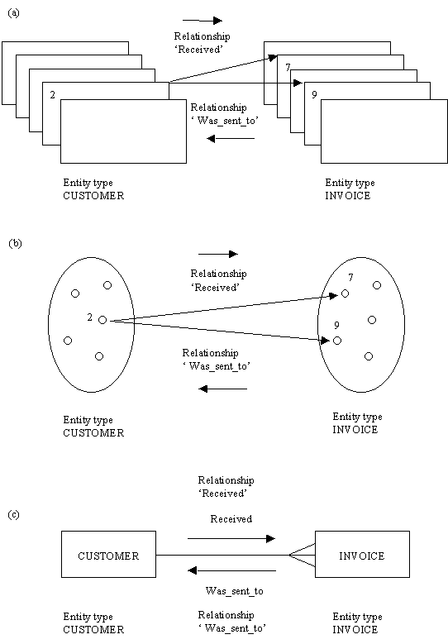
Fig. 3.5 Three ways of thinking of a relationship.
It was mentioned earlier that there is in fact a distinction between relationships and relationship types. In Fig. 3.5(a) and (b) there are in fact two relationships shown: one between customer 2 and invoice 7 and one between customer 2 and invoice 9, so strictly speaking ‘received’ is a relationship type consisting of a number of relationships between entity types. However, this distinction is sometimes dropped and both are given the name ‘relationship’.
Finally, note that relationships between entity types are represented in a relational database using foreign keys. The value of the primary key of one entity is placed in every entity of the second type to which it is related. This is discussed in detail later on in the course.
3.6 Ways of Classifying Relationships Types
A relationship type can be classified by the number of entity types involved, and by the degree of the relationship type, as is shown in Fig. 3.6. These methods of classifying relationship types are complementary. To describe a relationship type adequately, you need to say what the name of the relationship type and its inverse are and their meaning, if not clear from their names and you also need to declare the entity type or types involved and the degree of the relationship type that links the entities. We now discuss the latter two items.
The purpose of discussing the number of entity types is to introduce the terms unary relationship type, binary relationship type, and ternary relationship type, and to give examples of each. The number of entity types in the relationship type affects the final form of the relational database.
The purpose of discussing the degree of relationship types is to define the relevant terms, to give examples, and to show the impact that the degree of a relationship type has on the form of the final implemented relational database.
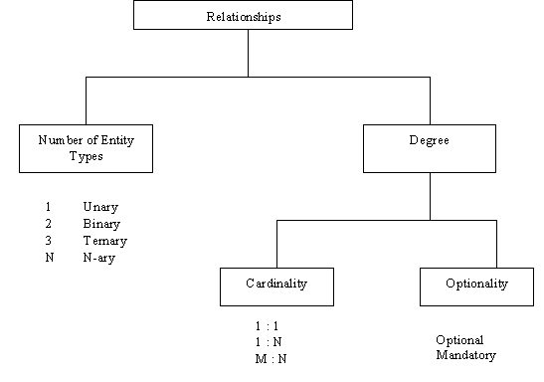
Fig. 3.6 Ways of classifying relationships.
3.6.1 Number of Entity Types
If a relationship type is between entities in a single entity type then it is called a unary relationship type. One example is the relationship ‘friendship’ between entities within the entity type PERSON. If a relationship type is between entities in one entity type and entities in another entity type then it is called a binary relationship type because two entity types are involved in the relationship type. An example is the relationship ‘Received’ in Fig. 3.4 and Fig. 3.5 between customers and invoices. Another example of a binary relationship type is ‘Purchased’ between entity types CUSTOMER and PRODUCT. Two entity types are involved so the relationship is binary.
It is possible to model relationship types involving more than two entity types. For example a LECTURER ‘recommends’ a certain TEXT on a certain COURSE. Here the relationship type is ‘recommends’. This relationship type is said to be a ternary relationship type since three entity types are involved. Examples of unary, binary and ternary relationship types are shown in Fig. 3.7.
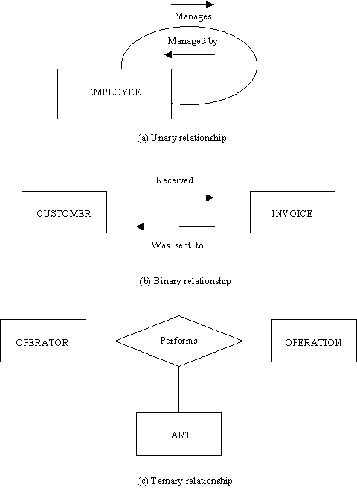
Fig. 3.7 There can be one, two, three or more entity types involved in a relationship.
It is sometimes possible to replace higher-order relationship types (ternary and above) by a collection of binary relationship types linking pairs of the original entity types. However this is not always possible (although as we shall see, in 3.6.1.1 below, the high-order relationship can always be redefined, with suitable renaming, as an entity type). In the example cited above concerning lecturers recommending textbooks on courses, it is not possible to replace the ternary relationship type ‘recommends’ with two or even three binary relationship types because information would be lost.
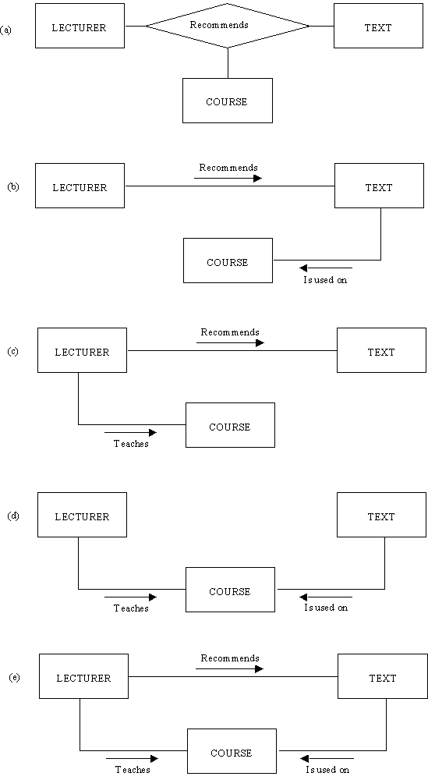
Fig. 3.8 (a) shows the ternary relationship type ‘recommends’ linking LECTURER, TEXT and COURSE.
In Fig. 3.8(b) an attempt has been made to replace the ternary relationship type with two binary relationship types. LECTURERs ‘recommend’ TEXTs and TEXTs ‘are_used_on’ COURSEs. The fact that a lecturer recommends a text and that text is used on a course does not necessarily mean that that lecturer recommended that text for that course. The text might be used on the course and recommended by someone else, whereas our lecturer does recommend that text but for a different course.
In Fig. 3.8(c) it is possible to tell which texts a lecturer recommends and which courses he or she teaches on, but not which texts are used on a course or which courses use a given text. The fact that a lecturer recommends a text and teaches a course does not imply that he or she recommends that text for that course.
In Fig. 3.8(d) it is possible to tell which courses a lecturer teaches and which texts a course uses but not which texts a teacher recommends. Only if every course had only one lecturer would (d) be satisfactory because then the fact that a course used a text implies who recommended it. Otherwise (d) is unsatisfactory.
In Fig. 3.8(e) it is possible to tell who recommends which texts, who teaches which courses, and which texts are used on which courses. However it is still not possible to ascertain, in general, the answers to questions like:
'Which text does Mr Smith recommend for the 4th year Database course?'
The reason is that even though Mr Smith may recommend text1 and Mr Smith teaches on 4th year Database, it is not known whether it was Mr Smith who recommended the text for the course, because he may have recommended the text for another course, and another lecturer on the 4th year Database course may have recommended text1. The only satisfactory relationship type is that shown in Fig. 3.8(a).
3.6.1.1 Removing Ternary relationship types
It is advantageous to remove ternary and higher order relationship types. One reason is that it might be considered more ‘natural’ to think of entity types having attributes than relationship types having them. It is in fact always possible to remove these high-order relationship types and replace them with an entity type. A ternary relationship type is then replaced by an entity type and three binary relationship types linking it to the entity types which were originally linked by the ternary. A quartenary relationship type would be replaced by an entity type and four relationship types and so on.
In Fig. 3.8(e), the ternary relationship type ‘recommends’ (verb) can be replaced with an entity type ‘recommendation’ (noun), and a binary relationship between it and each of the entity types LECTURER, TEXT and COURSE (three binary relationships in all). It is natural to think about the attributes of a recommendation but not so natural to think about the attributes of a relationship type ‘recommends’. Typical non-key attributes of the RECOMMENDATION might be DATE_RECOMMENDED and STATUS (whether the recommendation has been approved or not). Another advantage of replacing the ternary relationship type is that a ternary or higher-order relationship type cannot in any real sense have a direction. Another is that in Fig. 3.8(a) it is not clear from the diagram (without pre-existing contextual knowledge) what is recommending what to what. Does a lecturer recommend a course in a text? Or does a lecturer recommend a text for a course?
When the single ternary relationship type has been replaced by three binary relationship types, each of the relationships and their inverses can be named, lending considerably more semantic information to the diagram. Clearly, replacing the ternary has allowed us to convey more semantics about the real-world situation than before.
The general conclusion then is that the only relationship types that should be shown on the entity relationship diagram should be either unary (involving one entity type) or binary (involving two entity types).
As stated, the naming of the new entity type and the new relationship types is important. Inappropriately naming the entity type or omitting or inappropriately naming the relationship types will lead to misunderstanding and consequent incorrect processing of data (possibly caused by programmers misunderstanding the ‘meaning’ of the database schema) and incorrect data appearing on the database. As a general guide entity types should have noun names (e.g. RECOMMENDATION) and relationships should have the form of a verb (e.g. `made' or `concerned' or ‘was_for’).
We shall return to this example when we study Fourth Normal Form. That is one of the methods in Normalization, which is a more detailed and mechanical method of categorizing data.
3.6.2 The Degree of a Relationship Type
The second way of classifying relationship types is to state their degree. As stated in the preceding section, the number of entity types and the degree both have an important impact on the final design of the relational database. The use of terminology related to the degree of a relationship type varies between different authors (See Fig. 3.9). In this tutorial, we use the James Martin terminology.
Source | No. of entity types  in the relationship | Minimum number of participants in the relationship | Maximum number of participants in the relationship
Author 1: C.J. Date |  |  | Degree
Author 2: James Martin |  | Optionality | Cardinality
Author 3 |  | Optionality | Degree
Author 4 |  |  | Degree
Author 5 |  | Optionality | Cardinality and Degree
Author 6 | Degree | Minimum Cardinality | Maximum Cardinality
Author 7 |  |  | Degree
Fig. 3.9 Assorted usage of the entity-relationship terminology concerning relationships.
The degree of a relationship type concerns the number of entities within each entity type that can be linked by a given relationship type. Fig 3.10 shows how this degree is shown on an entity relationship diagram. There are two directions of a relationship type. Each is named and each has a minimum degree and a maximum degree.
3.6.2.1 Cardinality and Optionality
The maximum degree is called cardinality and the minimum degree is called optionality. In another context the terms ‘degree’ and ‘cardinality’ have different meanings. The term ‘degree’ is used to denote the number of attributes in a relation while ‘cardinality’ is the number of tuples in a relation. Here, we are not talking about relations (database tables) but relationship types, the associations between database tables and the real world entity types they model.
There are three symbols used to show degree. A circle means zero, a line means one and a crowsfoot means many. The cardinality is shown next to the entity type and the optionality (if shown at all) is shown behind it. Refer to Fig. 3.10(a). In Fig. 3.10(b) the relationship type R has cardinality one-to-many because one A is related by R to many Bs and one B is related (by R's inverse) to one A. Generally, the degree of a relationship type is described by its cardinality. R would be called a 'one-many' or a ‘one-to-many’ or a ‘1 : N’ relationship type. To fully describe the degree of a relationship type however we should also specify its optionality.
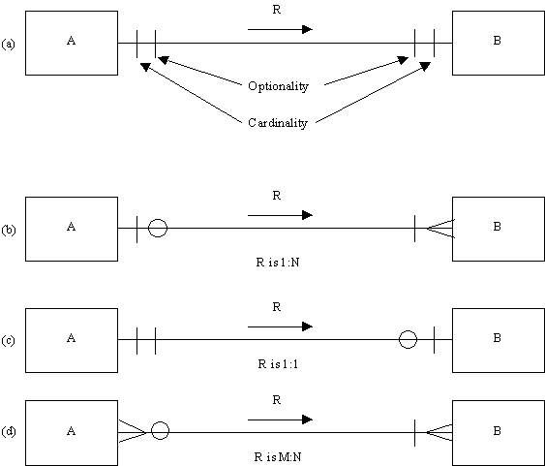
Fig. 3.10 Relationship degree.
The optionality of relationship type R in Fig. 3.10(b) is one as shown by the line. This means that the minimum number of Bs that an A is related to is one. A must be related to at least one B. Considering the optionality and cardinality of relationship type R together, we can say that one A entity is related by R to one or more B entities. Another way of describing the optionality of one, is to say that R is a mandatory relationship type. An A must be related to a B. R's optionality is mandatory. With optionality, the opposite of ‘mandatory’ is optional. In Fig. 3.10(b) the inverse of R happens to be optional, as shown by the circle. The inverse of R is an optional relationship type. This means that one B might not be related (by the inverse of R) to any A. There may be a B entity not related to any A entity. Considering the optionality and cardinality of the inverse of R together, we can say that a B entity is related (by the inverse of R) to zero or one A entities.
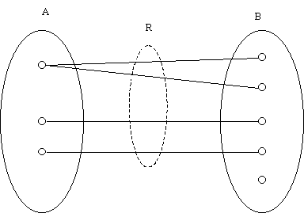
Fig. 3.11 A set diagram representation of Fig. 3.10(b).
The case of Fig. 3.10(b) is shown in the form of a set diagram in Fig 3.11. The two entity types A and B are shown as sets (the oval shapes). The entities are shown as small boxes: elements in the sets. The relationship type R links A entities to B entities. It shows which A entities are related to which B entities. Notice that it is possible for an A entity to be related to one or more B entities. The maximum number of Bs for a given A is ‘many’ (for example the first A entity is related to two Bs) and the maximum number of As for a given B is one. This establishes the one-many cardinality of R. The minimum number of Bs for a given A is 1. (There are no A entities without a B entity). This establishes mandatory optionality of R. There can exist a B that is not related to any A; for example the last B entity. This establishes the ‘optional’ optionality of the inverse of R.
Fig. 3.12 summarizes the terminology in another example.
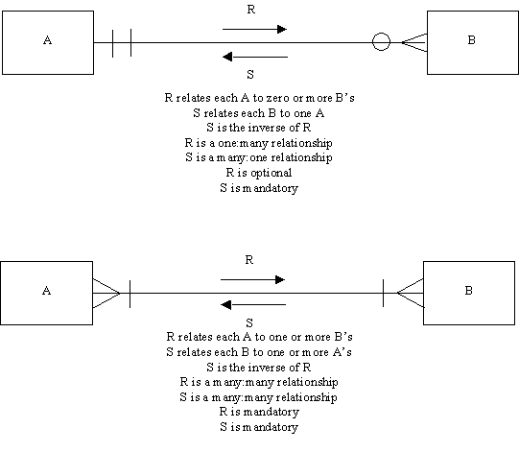
Fig. 3.12 More examples of our relationship terminology.
3.6.2.2 Deriving a One-Many relationship type
In Fig. 3.13 the procedure for deriving the degree of a relationship type and putting it on the entity relationship diagram is shown. The example concerns part of a sales ledger system. Customers may have received zero or more invoices from us. The relationship type is thus called ‘received’ and is from CUSTOMER to INVOICE. The arrow shows the direction. The minimum number of invoices the customer has received is zero and thus the ‘received’ relationship type is optional. This is shown by the zero on the line. The maximum number of invoices the customer may have received is ‘many’. This is shown by the crowsfoot. This is summarized in Fig. 3.13(a). To complete the definition of the relationship type the next step is to name the inverse relationship type. Clearly if a customer received an invoice, the invoice was sent to the customer and this is an appropriate name for this inverse relationship type. Now consider the degree of the inverse relationship type. The minimum number of customers you would send an invoice to is one; you wouldn't send it to no-one. The optionality is thus one. The inverse relationship type is mandatory. The maximum number of customers you would send an invoice to is also one so the cardinality is also one. This is summarized in Fig. 3.13(b). Fig. 3.13(b) shows the completed relationship.
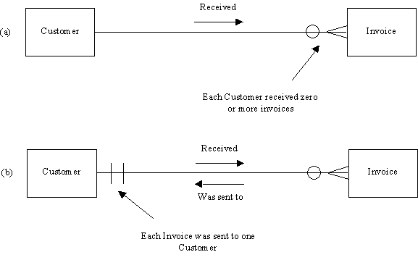
Fig. 3.13 Deriving a 1:N (one:many) relationship.
A word of warning is useful here. In order to obtain the correct degree for a relationship type (one-one or one-many or many-many) you must ask two questions. Both questions must begin with the word ‘one’. In the present case (Fig. 3.13), the two questions you would ask when drawing in the relationship line and deciding on its degree would be:
Question 1: One customer received how many invoices?
Answer: Zero or more.
Question 2: One invoice was sent to how many customers?
Answer: One.
This warning is based on observations of many student database designers getting the degree of relationship types wrong. The usual cause of error is only asking one question and not starting with the word ‘one’. For example a student might say (incorrectly): ‘Many customers receive many invoices’ (which is true) and wrongly conclude that the relationship type is many-many. The second most common source of error is either to fail to name the relationship type and say something like ‘Customer to Invoice is one-to-many’ (which is meaningless) or give the relationship type an inappropriate name.
3.6.2.3 Deriving a Many-Many relationship type
Fig. 3.14 gives an example of a many-many relationship type being derived.
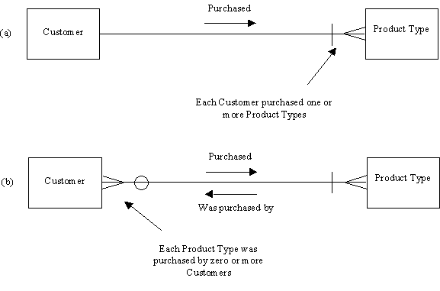
Fig. 3.14 Deriving a M:N (many-many) relationship.
The two questions you have to ask to correctly derive the degree of this relationship (and the answers) are:
Question 1: One customer purchased how many product types?
Answer: One or more.
Question 2: One product type was purchased by how many customers?
Answer: Zero or more.
Note that the entity type has been called PRODUCT TYPE rather than PRODUCT which might mean an individual piece that the customer has bought. In that case the cardinality of 'was_purchased_by' would be one not many because an individual piece can of course only go to one customer. This point is another common source of error: the tendency to call one item (e.g. an individual 4" paintbrush) a product and the whole product type (or 'line') (e.g. the 4" paintbrush product type) a product. You should make the meaning clear from the name you give the entity type.
We have assumed here that every customer on the database has purchased at least one product; hence the mandatory optionality of ‘purchased’. If this were not true in the situation under study then a zero would appear instead. The zero optionality of 'was_purchased_by' is due to our assumption that a product type might as yet have had no purchases at all.
In practice it is wise to replace many-many relationship types such as this with a set (often two) of one-many relationship types and a set (often one) of new, previously hidden entity types. This is covered in a later section in this tutorial.
3.6.2.4 Deriving a One-One relationship type
Fig. 3.15 gives an example of a one-one relationship type being derived. It concerns a person and his or her birth certificate. We assume that everyone has one and that a certificate registers the birth of one person only.
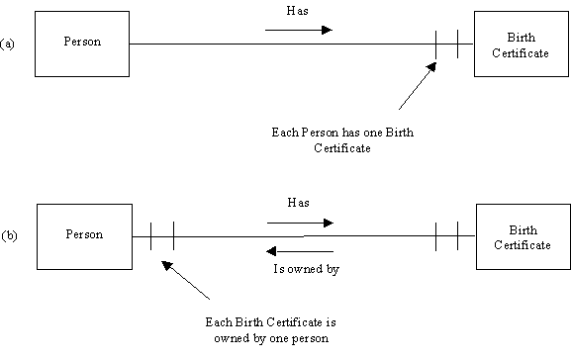
Fig. 3.15 Deriving a 1:1 (one:one) relationship.
Question 1: How many birth certificates has a person?
Answer: One.
Question 2: How many persons is a birth certificate owned by?
Answer: One.
Where there is a one-one relationship type we have the option of merging the two entity types. The birth certificate attributes may be considered as attributes of the person and placed in the person entity type. The birth certificate entity type would then be removed. There are two reasons for not doing this. Firstly, the majority of processing involving PERSON records might not involve any or many of the BIRTH_CERTIFICATE attributes. The BIRTH CERTIFICATE attributes might only be subject to very specific processes which are rarely executed. The second reason for not merging might be that the BIRTH CERTIFICATE entity type has relationship types to other entity types that the PERSON entity type does not have. The two entity types have different relationship types to other entity types.

3.6.3 Mutually Exclusive relationship types
In some cases the existence of one kind of relationship type precludes the existence of another. Entities within an entity type A may be related by a relationship type R to an entity in entity type B or entity type C but not both. The relationship types are said to be mutually exclusive. Usually both relationship types will have the same name, as in the following example. In Fig. 3.16 a fault report may have been for a computer or a printer but not both. The fact that it might not have concerned a computer is shown by the zero optionality of the upper 'was_for' relationship type between FAULT REPORT and COMPUTER. The fact that it might not have concerned a printer is shown by the zero optionality of the lower 'was_for' relationship type between FAULT REPORT and PRINTER. However a fault report must have been for either a computer or a printer (in this example). The zero optionality cannot apply for both. Both this and the fact that the fault report can have been for a maximum of one of the two entity types is indicated by the arc on the diagram linking the two relationship types. In summary then, the arc shows that a fault report can be for a maximum and a minimum of one entity from the types COMPUTER and PRINTER.
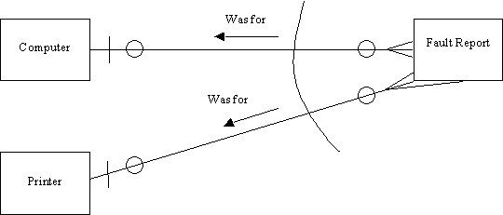
Fig. 3.16 A mutually exclusive relationship 'Was for'.
The set of relationship types is normally assumed to be exhaustive in one sense (i.e. there are not any other relationship types) because it is customary to put all relationships of interest on the diagram. However the set of relationship types might not be exhaustive in the sense that a given entity A might not be related to an entity in any of the other entity types in the group marked by the arc. This second type of exhaustiveness (or lack of it) cannot be shown using this arc device.
Another limitation of the arc device is that it cannot show excluded and mandatory combinations of permitted relationships. For example, it might be the case that an entity in type A might be related to some subset of entities from types B, C and D. It might be that if it is related to a B and a C then it cannot be related to a D entity. It might be that if it is related to a B then it must also be related to either a C or D but not both.
A further constraint type that may be required in practice is that an entity of type A may legally be related to any n entities from a selection of m entity types.
The suggestion being made here is that current methods for drawing entity relationship diagrams could be extended to allow these types of relationship constraints to be shown on the diagram.
3.6.4 Redundant Relationship Types
In Fig. 3.17 there is a 'received' relationship type between CUSTOMER and INVOICE and an 'obtained' relationship type between INVOICE and PAYMENT. It is possible via 'received' to find which invoices have been received by a given customer. It is possible to find the customer an invoice was sent to via the 'was_sent_to' relationship type (the inverse of ‘received’). Using the 'obtained' relationship type it is possible to find the payments that a given invoice has received and via its inverse 'was_posted_to', the invoice that a payment was posted to. Using the composition of 'received' and 'obtained' (that is, using one relationship type followed by the other), it is possible to find all the payments that a given customer has made. By navigating from CUSTOMER to INVOICE and thence to PAYMENT this can be done.
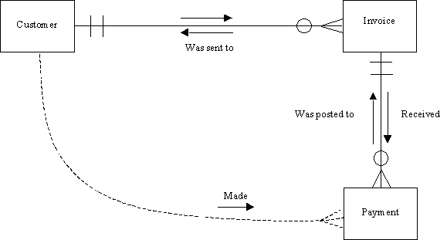
Fig. 3.17 The 'Made' relationship is redundant.
Similarly, it is possible to find the sender of a payment using the composition of the two relationship types 'was_posted_to' and 'was_sent_to', navigating from PAYMENT to INVOICE to CUSTOMER.
If an extra (direct) relationship type from CUSTOMER to PAYMENT were to be implemented it would be redundant. If it showed only which customer sent a payment and (via its inverse) which payments a customer made, it would be unnecessary because it shows nothing that cannot be shown using compositions of the other two relationship types.
In general, when there are loops in your entity relationship diagram, be on the lookout for the possibility of breaking the loop at some point by removing a relationship type that can be synthesized from the composition of other relationship types on the diagram. This is often not possible because of the nature of the relationships i.e. their meaning.
In some rare cases you might consider it advisable to introduce a logically redundant relationship type simply out of consideration of efficiency.
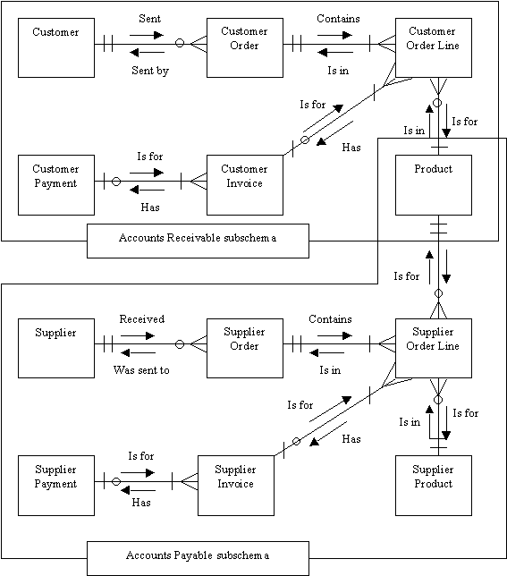
Fig. 3.18 An entity-relationship diagram for a simple accounting system.
Fig. 3.18 shows the entity relationship diagram for a relatively simple accounting system. The top grouping of entity types and relationship types constitute a sales ledger ('accounts receivable' and 'debtors ledger' are two other names for this). The whole diagram will be used as a schema for the database holding such data and the sales ledger entity types and relationship types will be called the sales ledger subschema. The bottom subschema is the accounts payable subschema (also called the 'purchase ledger', because it shows what the company has purchased from its suppliers). Notice that sub-schemas may overlap, as here. The PRODUCT entity type is used in both contexts; sales and purchasing. Products are purchased and they are sold.
Returning to the subject of redundant relationship types, let us consider placing a 'redundant' relationship type between the entity type CUS and the entity type CUS_PAYMENT. There are many queries that could be answered using the schema shown, including:
'List all payments made by customer X'.
The problem with this query is that to answer it, it is necessary to navigate via four relationship types. Using the first relationship type 'made', all the customer orders are accessed. For each order, 'Contains' is used to access every order line. For each order line, the customer invoice (if any; an invoice might not yet have been sent. This is shown using an 'optional' circle at the left-hand end of the relationship type) is accessed and the payment is retrieved and then listed. The pseudo-code for this could be written as shown in Fig. 3.19.
RETRIEVE CUS record
OBTAIN customer's account number
RETRIEVE first CUS_ORDER record for this account
DOWHILE not end of CUS_ORDERs
OBTAIN order's order number
RETRIEVE first CUS_ORDER_LINE record for this order number
DOWHILE not end of CUS_ORDER_LINEs
OBTAIN order line's invoice number
IF invoice number is not null
RETRIEVE CUS_INVOICE record for this inv no
OBTAIN invoice's payment number
IF invoice's payment number is not null
RETRIEVE PAYMENT record for this pmt no
LIST payment details
ENDIF
ENDIF
RETRIEVE next CUS_ORDER_LINE record for this order no
ENDWHILE
RETRIEVE next CUS_ORDER for this account number
ENDWHILE
Fig. 3.19 Pseudo Code for 'List all payments made by Customer x'
This pseudo-code assumes that a customer order line that has not yet been invoiced is indicated by a null value for the invoice number attribute in the order line and that an invoice that has not yet been paid is indicated in a similar way using a null value for the payment number in the invoice record. It must be noted also that this pseudo-code may be considered rather ‘physical’ since it talks about records rather than real-world entities. However in general every entity of interest will be modeled by a database record. Also, in a relational database, the relationship types are shown using foreign keys such as invoice number in CUS_ORDER_LINE and payment_no in CUS_INVOICE. In other types of database, in particular the older network (CODASYL) and hierarchical databases, foreign keys are not used so the details of the pseudo-code in Fig. 3.19 would be different. How relationship types are represented, including a discussion of foreign keys is later in the course.
The pseudo-code might be considered rather complex for such a simple query. It can be considerably simplified by adding a ‘redundant’ direct relationship type from CUS to CUS_PAYMENT. A foreign key (the customer's account number) would be placed in CUS_PAYMENT as an extra attribute. While unnecessary, as we have said, this relationship type is advantageous in that the pseudo-code for the query is now as shown in Fig. 3.20, which is much simpler.
RETRIEVE CUS record
OBTAIN customer's account number
RETRIEVE first CUS_PAYMENT record
DOWHILE not end of CUS_PAYMENTs
RETRIEVE PAYMENT record for this account number
LIST payment details
RETRIEVE next CUS_PAYMENT for this account number
ENDWHILE
Fig. 3.20 Simplified Pseudo Code for 'List all payments made by Customer x'
In summary, redundant relationship types should be identified and in general removed. However, implementing a redundant relationship type into the database schema may make the programming of some queries, reports and updates simpler. The major disadvantage of having redundant data on the database is that it may lead to inconsistency. The redundant one-many relationship type we are considering putting between CUS and CUS_PAYMENT would be implemented by placing a foreign key (the customer's account number) into the CUS_PAYMENT entity type. If this value was different from the value obtained by navigating back via the long route (CUS_PAYMENT, CUS_INVOICE, CUS_ORDER_LINE, CUS_ORDER, CUS) then this would constitute an inconsistency.
Entity Relationship Modeling - Summary
1. An entity type is a type of entity you want to store data about. The data is stored in the form of attributes. An individual within an entity type is an entity. Each entity in an entity type has a different value of the entity type’s primary key.
2. Entity types are linked by relationship types. A relationship type is a type of relationship in the real world that you want to represent on the database. An individual within a relationship type is a relationship.
3. Relationship types are binary or unary. Ternary and higher order relationship types can always be replaced with binary relationship types and entity types.
4. Relationship types have two directions, may have degree one-one, one-many or many-many, and may be mandatory or optional in either direction.
5. Redundant relationship types may occasionally be modeled and implemented to improve performance.
6. Many-many relationship types should always be split to reveal entity types and relationship types that might otherwise remain hidden.
7. Relationship types must always be named in both directions. There can be more than one relationship type between entity types. The names distinguish them.
8. It should be possible to ‘read’ an entity-relationship diagram which should represent a set of simple subject-verb-object sentences. Subject and object are entity types. Relationship types correspond approximately to verbs. An entity-relationship model should explain itself. An unclear or ambiguous model does more harm than good, since it might mislead. The good entity modeler is good at grammar, good at spotting ambiguity, and uses the simplest words.
9. When drawing an entity-relationship model, don't assume anything; rather write a list of questions you would have to find answers to complete the model. State any assumptions you are aware of having made.
Assignment - Complete all 4 parts as described below.
Exercise 1 - CARS
Identify all entity types, attributes, relationship types and their degrees in the following case. Hence draw an entity-relationship diagram.
An organization makes many models of cars, where a model is characterized by a name and a suffix (such as GL or XL which indicates the degree of luxury) and an engine size.
Each model is made up from many parts and each part may be used in the manufacture of more than one model. Each part has a description and an id code. Each model of car is produced at just one of the firm’s factories, which are located in London, Birmingham, Bristol and Manchester - one in each city. A factory produces many models of car and many types of part although each type of part is produced at one factory only.
Exercise 2 - A UNIVERSITY
A university consists of several faculties. Within each faculty there are several departments. Each department may run a number of courses. All teaching staff is attached to departments, each staff member belonging to a unique department. (Note: see how many meanings you can assign to this ambiguous sentence). Every course is composed of sub-courses. Some sub-courses are part of more than one course. Staff may teach on many sub-courses and each sub-course may be taught by a number of staff.
Draw an entity-relationship model for this example. Show both cardinalities and optionalities. Put a question mark where the degree is not clear from the text. Don't assume anything; rather, write a list of questions you would have to find answers to in order to complete the model.
Exercise 3 - MORTGAGES
Draw an entity-relationship diagram for the following. Produce also a list of questions you would have to have answered in order to complete the model.
In a case study of this kind, and in particular in exam questions, there is not usually the space to completely specify a problem. Remember also that not all the information given in a case study of this type is necessarily relevant. Some information, while relevant to the organization concerned, might not be relevant as far as database design is concerned.
Members of a friendly society invest money in any one of the society's branches. A member may hold a number of investment accounts. Each investment account is associated with the branch where it was opened, but money may be paid in or withdrawn at any branch. For each account, the member holds an account book to record all transactions. A member may also have one mortgage account. All mortgage accounts are associated with the Head Office. Payments may be transferred from any investment account into the mortgage account.
Exercise 4 - SALES LEDGER AND STOCK CONTROL
ABC Ltd plans to computerize its sales ordering and stock control system. A feasibility study has strongly suggested that a relational database system be installed. The details of ABC's sales and stock control are as follows:
Customers send in orders for goods. Each order may contain requests for variable quantities of one or more products from ABC's range. ABC keeps a stock file showing for each product the product details and the preferred supplier, the quantity in stock, the reorder level and other details.
ABC delivers those goods that it has in stock in response to the customer order and an invoice is produced for the dispatched items. Any items that were not in stock are placed on a back order list and these items are usually re-ordered from the preferred supplier. Occasionally items are ordered from alternative sources.
In response to the invoices that are sent out to ABC's customers, the customers send in payments. Sometimes a payment will be for one invoice, sometimes for part of an invoice and sometimes for several invoices and part-invoices.
Draw an entity-relationship model, stating any assumptions made.

What to Hand In:

Email your assignment files for all parts in one email message to barbara.hecker@csueastbay.edu with the subject line of [your last name] + “Assign1”
You may use any drawing program you want or do the diagrams by hand and scan them into files to send to me. You can also just print them out and give them to me in class if you don’t want to bother emailing them.
A good drawing program is SmartDraw downloaded for free at: http://www.smartdraw.com/downloads/

Late Policy: There is a seven day grace period. This assignment will be counted late on the eighth day after the due date. Starting with the eighth day, you will receive a 10% point deduction PER DAY for lateness.

Academic Dishonesty: All of your programming assignments need to represent your own effort. Programs should be done without consultation with other students and you should not share your source code with others. Any program submitted that is essentially the same, as someone else’s will not be accepted. ALL matching assignments will receive 0 credits.

