CS 455 – Computer Graphics
Assignment #6 (WebGL)

An Interactive Vehicle of your Choice
For this assignment you are to start with your WebGL program that contains a vehicle (assignment 5). Your task in this assignment is to create a game from your assignment 5 car and scene. You may make any alterations you wish from your assignment 5 submission to create enhancements and extra features for your game.
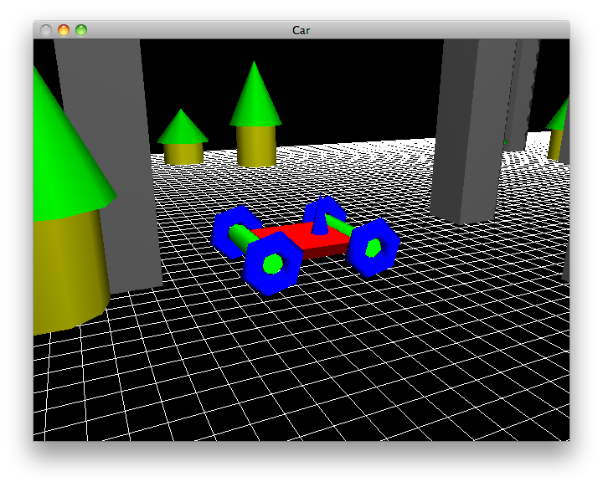
Feature Description
- You should already have interactive controls for the user to move the vehicle using the keyboard and/or mouse. Modify or enhance these controls to make them useful for your game behavior.
- If you have not done so already, add functionality to detect if your vehicle has collided with any of your other objects in the scene. You should keep track of at least two different kinds of objects and detect when the vehicle has collided with either object specifically.
- Your vehicle should not be able to move off the grid. Bounds checking should be performed to keep the character in its world.
- Add sound to your game so that audio effects can be heard when the collisions are detected.
- Create a scoring system to keep track of how well the user is navigating the vehicle. The scoring may implement your own game logic. If you are not creative than you can keep a simple count for how many times the user has collided with each type of object. You may also consider how many times the user has attempted to go out of bounds.
- Develop some win/loss logic and keep track of the user’s performance. Display the users scoring statistics somewhere on the screen.
You may use ANY WebGL library you wish as long as it works with JavaScript and runs in a web browser. For example, Three.js, SceneJS, PhiloGL, SpiderGL, and many more can be found at http://www.khronos.org/webgl/wiki/User_Contributions
Email your source code to barbara.hecker@csueastbay.edu. All I need is your html and JavaScript code. I do not need your audio files or any graphic images you have added to the website outside of the WebGL code. If you have created an external CSS file, please include that as well.

