CS 455 – Computer Graphics
Assignment #4 (OpenGL in C/C++ or Java)

An Interactive Robot Arm
Part 2 – Lights, Camera, Action!
Using OpenGL in C/C++ or Java, you have already created an interactive robot arm as shown.
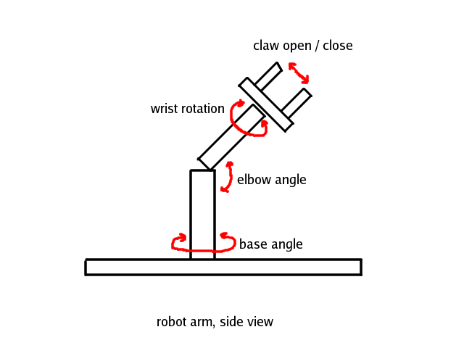
Leave the existing functionality in place and add the following new features to your scene.

Materials - Your robot arm should have material properties. When the hierarchical object is displayed, each 3D primitive should have its own material properties. The properties should include ambient, diffuse, and specular (RGB) colors and shininess.
You should also add a normal-as-color scheme, which is a useful tool to check the geometry of your objects before you implement lighting. It works as follows: consider that the (x, y, z) components of a unit normal vector lie between -1 and 1, while the floating point RGB values of a color lie between 0 and 1. To produce a color display that is indicative of the normal direction, we simply use the (x, y, z) values of the normal as the RGB components of the color using the formula RGB = ((x, y, z) + 1)/2 to map the values to the range [0,1]. This gives you better idea of the geometry of your object than a flat shaded polygon. This mode should be activated when lighting is switched off (see below).

Lights - Your scene should have three lights (although you can add more if you like). You may choose from positional v. directional style and ambient, diffuse, and specular colors. You should also be able to turn individual lights on and off. There should also be a global ambient light that allows you to see the current object when all lights are turned off. The position of your lights should be fixed in the scene, independent of camera motion. Additionally, add a global switch to turn lighting off, and render your object using the normal-as-color scheme described in the Materials section above.

Camera motion: You should implement at least one camera in your scene. You are welcome to implement more. If you can figure out one, its easy to add more.

If you are using JOGL (Java) you need to use the gluLookAt() method. For C/C++ you need to use LookAt(). The libraries work in similar ways.

To enable you to see the objects on the screen from many viewpoints, you need to implement interactive camera controls to move the camera. The camera motion in your viewer should be triggered by mouse or key board presses. You only need to move one camera in our scene but you are welcome to have more cameras and move them all interactively.

The following OpenGL Tutorial might help you with Materials, Camera and Lighting: https://learnopengl.com/Getting-started/Camera

For the Camera controls in JOGL the following resource should get you started:
https://beta.wikiversity.org/wiki/Computer_graphics_--_2008-2009_--_info.uvt.ro/Laboratory_7#Camera_control

Email your source code to barbara.hecker@csueastbay.edu.

