Entity-Relationship Diagram Examples (ERD)

- A software program manages rental property. A rental agreement is drawn up with the customer for each property rented. A customer may rent more than one property.

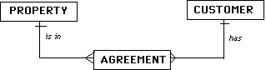

- A travel company specializes in offering camping sites in popular resorts. Each site has a number of plots that can be booked by travelers for a number of days. One individual in each party is responsible for the booking, which may request more than one plot if the party is big. The company likes to keep details about all the individuals on a booking for marketing and payment purposes.

