What You Need for This Project

LEGAL WARNING!
It's OK to do the puzzles at HackThisSite.org, but DO NOT HACK INTO OTHER COMPUTERS! Accessing computers without permission from the owners is a crime! Don’t do it! If you do illegal things, you may be arrested and go to jail, and I will be unable to save you. This project will teach you more about criminal hackers—understand them, but do not imitate their morals.
- A computer of any kind with Internet access.
- A lot of time to spend solving puzzles and doing research. Be warned—these puzzles can take a lot of time, and require advanced techniques beyond any textbook or course.
Part I: Basic Web Challenges
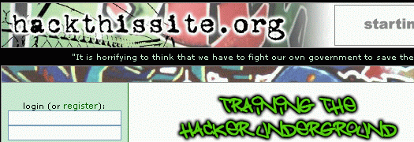
- Be warned: in this project, you will be learning real criminal techniques from real criminals. Do not reveal your real name or address, or trust these people. As you will see in Part II, the creator of this site is currently in prison. If you prefer not to do this project, you don't need to.
- Open a browser and go to hackthissite.org
- In the upper left, click on the green word register.
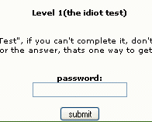
- Fill out the form to create an account. Do NOT give these people your real name or any correct information, not even a real email address. I used the address test@mailinator.com and I recommend that you use a mailinator address too.
- After creating your account, log in. Then, on the upper left of the main page, in the challenges section, click "Basic Missions."
- You should see a page labeled Level 1(the idiot test). There is a form asking for a password. Your job is to figure out the password. There is a Help! Link at the bottom which can help you.
- Solve as many puzzles as you can. There is a forum on the site which contains hints, tutorials, and even outright explicit instructions at solving the puzzles. The puzzles are very instructive, although not perfect. In my opinion level 8 is too frustrating—the code injection routine is too restrictive, so you don't get enough reward for coming close to the answer. But that's because the technique being used is so powerful that you could take over the whole hackthissite.org server, so they have to protect themselves.
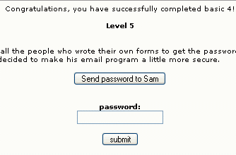
- When you have completed as many levels as you can, or want to, take a screen image showing how far you got, as shown to the right on this page.
Saving the Screen Image
- Press the PrntScn key to copy the desktop to the clipboard.
- On the Start menu, click Run. Enter the command mspaint and press the Enter key. Paint opens.
- Press Ctrl+V on the keyboard to paste the image into the Paint window. Save the document in the Shared Documents folder with the filename Your Name Assign1. Select a Save as type of JPEG. Close Paint.

Part II: Jeremy Hammond's Ethics and Fate
- At the main hackthissite.org page, in the upper left, click Realistic Missions. Look through the missions, as shown below, and think about them from an ethical point of view, not a technical point of view.

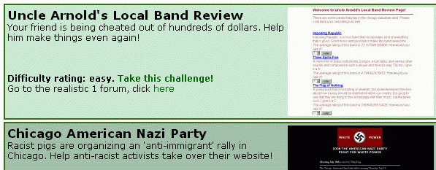

- Open a browser and go to en.wikipedia.org/wiki/Jeremy_Hammond
- Read what Jeremy did, and what happened to him.
- Write a 1-page report about Jeremy Hammond and his case. Make sure to address these points:
  - Was Jeremy Hammond an Ethical Hacker? Why or why not?
  - Was his sentencing fair? Should it have been more or less severe? Why?

Turning in your Project
- Email the JPEG images to me as attachments to one e-mail message to barbara.hecker@csueastbay.edu with the subject line of [your last name] + “Assign1.”
- Put your Part II discussion in the body of the email message or in an MS Word file attachment.

